**Problem Statement**

1. Say True or False for the below statements:

• Prescriptive Analytics used to predict the future outcomes?

• Base R packages installed automatically?

1. What is Recycling of elements in a vector?
2. Give an example of recycling of elements.

**Solution**

1.

* False , Prescriptive analytics is just a advise on possible outcomes .
* False , it can be installed through CRAN

2. While applying an operation to two vectors that expects them to be a similar length, R consequently reuses, or rehashes, components of the shorter one, until the point when it is sufficiently long to coordinate the longer vector.

3. example :

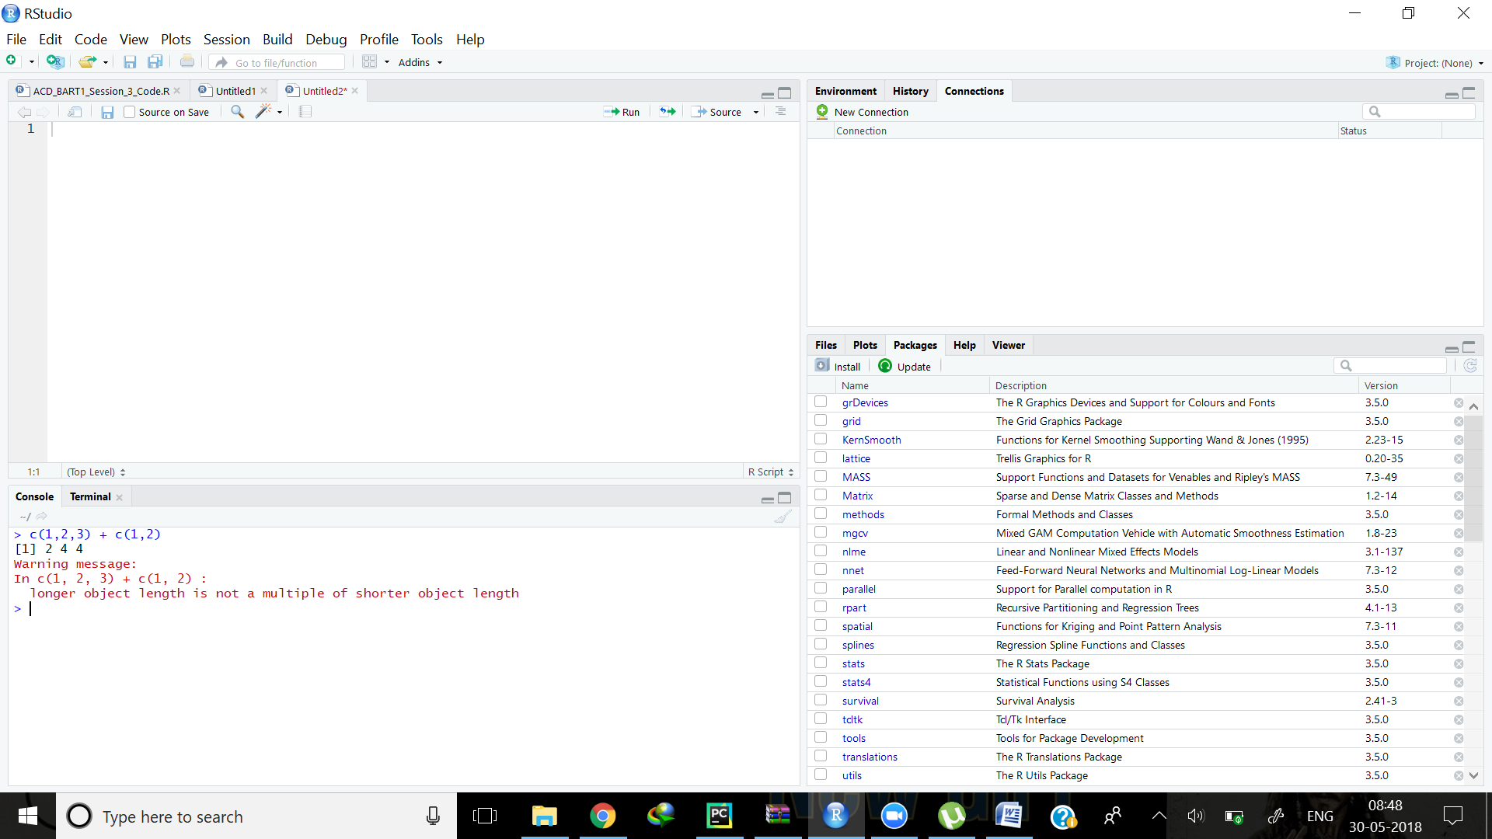

As seen , the c(1,2) vector repeated itself to form c(1,2,1) so that it could successfully coordinate the previous term.